**به نام خدا**

**عنوان:**

تکلیف شماره دوم درس طراحی سیستم‌های دیجیتالی

**نام درس:**

طراحی سیستم‌های دیجیتالی

**استاد درس:**

دکتر مروستی

**اعضا:**

محمدعلی مجتهدسلیمانی-992023039

**تاریخ:**

20/02/1403

**Question 1**

**Q1.** For verify a 4-bit carry look-ahead adder we should first make a test bench to simulate all possible inputs and check the outputs against expected values which test bench going to do that. For the following code I assumed that you already have a Carry-Look-Ahead Adder module, for my code I already done it in first homework question 4.

* **Main code for implement partial full adder:**

library IEEE;

use IEEE.STD_LOGIC_1164.ALL;

-- Define the entity for the Partial Full Adder

entity partial_full_adder is

Port (

A : in STD_LOGIC; -- Input bit A

B : in STD_LOGIC; -- Input bit B

Cin : in STD_LOGIC; -- Carry input

S : out STD_LOGIC; -- Sum output

P : out STD_LOGIC; -- Propagate output

G : out STD_LOGIC -- Generate output

);

end partial_full_adder;

-- Architecture declaration using a behavioral model

architecture Behavioral of partial_full_adder is

begin

-- Generate the Sum (S) output

S <= A xor B xor Cin;

-- Generate the Propagate (P) output

P <= A or B;

-- Generate the Generate (G) output

G <= A and B;

end Behavioral;

* **Complication Report:**

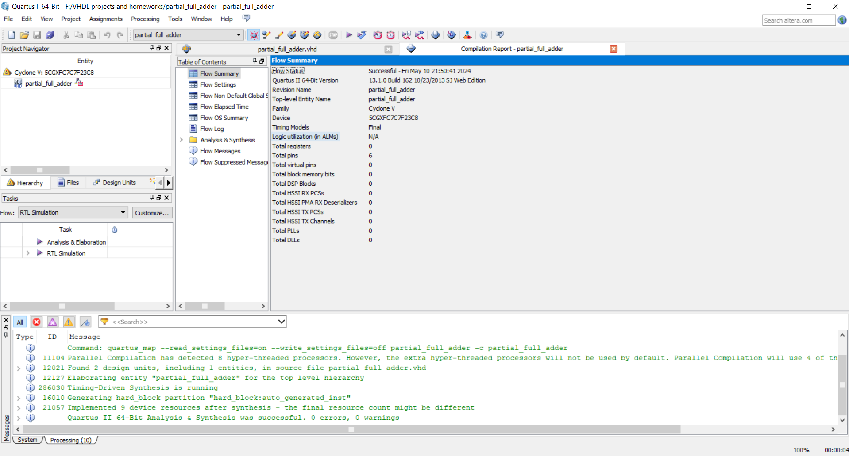

* **RTL view:**

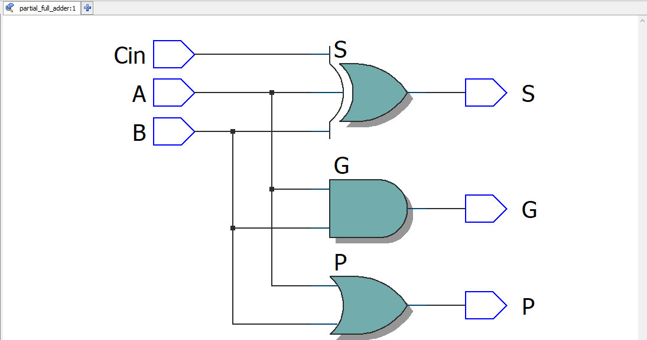

* **Post-mapping view:**

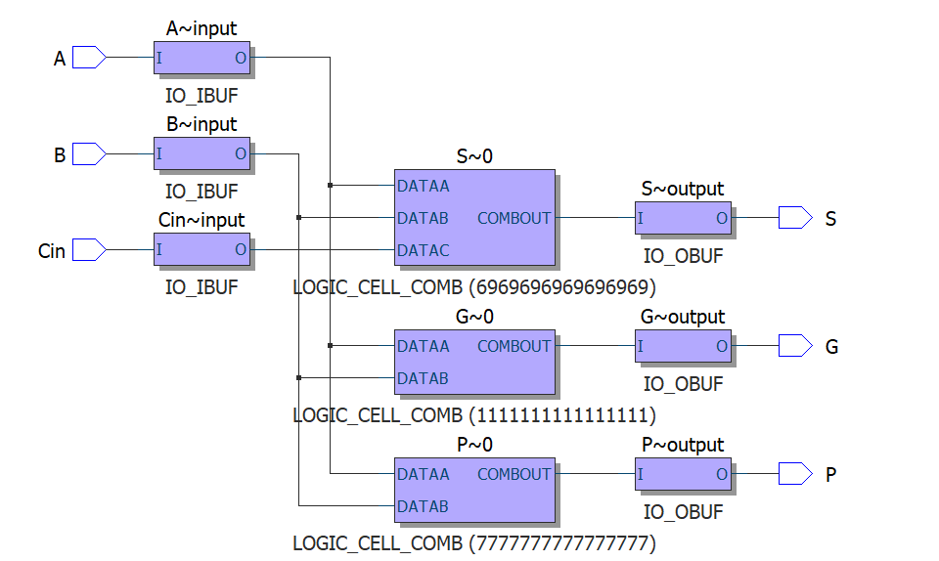

* **Wave Form:**

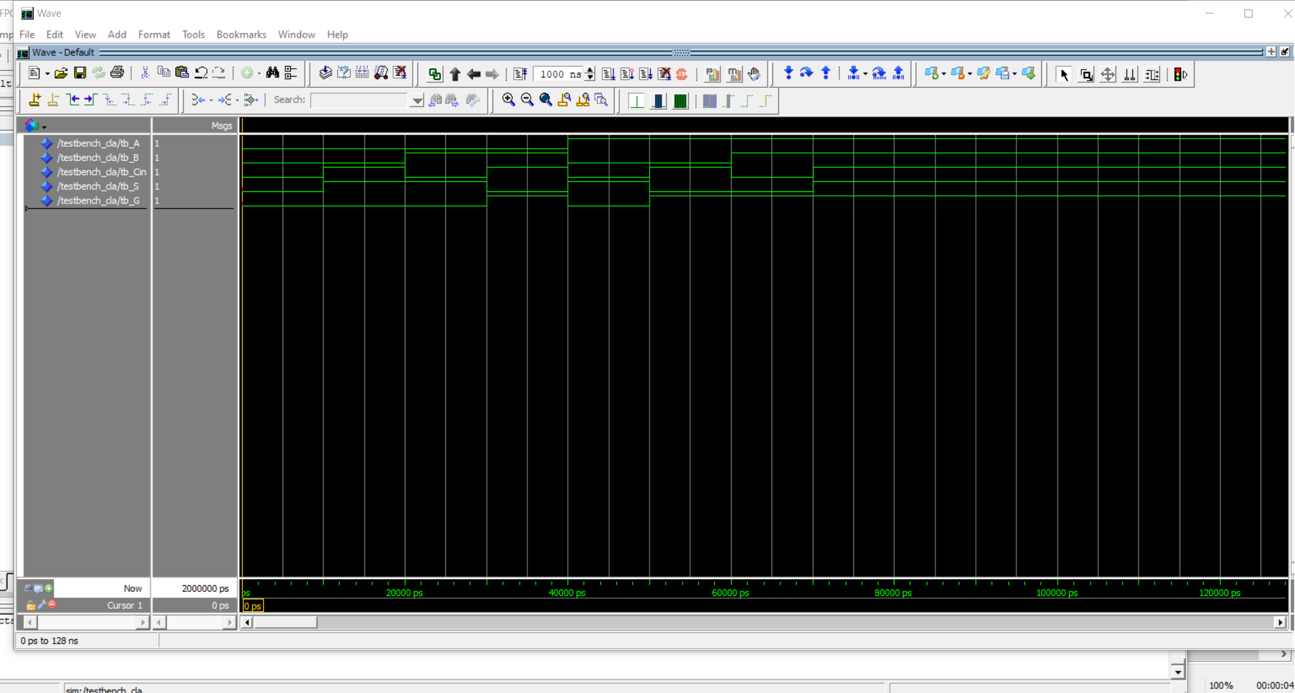

* **Test bench code:**

library IEEE;

use IEEE.STD_LOGIC_1164.ALL;

-- Define the test bench entity

entity TestBench_CLA is

-- Testbench does not have any ports

end TestBench_CLA;

architecture behavior of TestBench_CLA is

-- Component Declaration for the Carry Adder

component carry_adder

Port (

A : in STD_LOGIC;

B : in STD_LOGIC;

Cin : in STD_LOGIC;

S : out STD_LOGIC;

G : out STD_LOGIC

);

end component;

-- Signals for interfacing with the component

signal tb_A, tb_B, tb_Cin : STD_LOGIC := '0';

signal tb_S, tb_G : STD_LOGIC;

begin

-- Instantiate the Unit Under Test (UUT)

uut: carry_adder port map (

A => tb_A,

B => tb_B,

Cin => tb_Cin,

S => tb_S,

G => tb_G

);

-- Stimulus process

stim_proc: process

begin

-- Test all input combinations

tb_A <= '0'; tb_B <= '0'; tb_Cin <= '0';

wait for 10 ns;

tb_A <= '0'; tb_B <= '0'; tb_Cin <= '1';

wait for 10 ns;

tb_A <= '0'; tb_B <= '1'; tb_Cin <= '0';

wait for 10 ns;

tb_A <= '0'; tb_B <= '1'; tb_Cin <= '1';

wait for 10 ns;

tb_A <= '1'; tb_B <= '0'; tb_Cin <= '0';

wait for 10 ns;

tb_A <= '1'; tb_B <= '0'; tb_Cin <= '1';

wait for 10 ns;

tb_A <= '1'; tb_B <= '1'; tb_Cin <= '0';

wait for 10 ns;

tb_A <= '1'; tb_B <= '1'; tb_Cin <= '1';

wait for 10 ns;

-- Complete the simulation

wait;

end process;

end behavior;

**Question 2**

**Q2.** For a T flip flop, we the next state of flip flop driven by XOR T (input of circuit) and Q which is the current state of our circuit so based on this and based on t ff truth table I wrote a code for it. First here is a truth table of t ff:

* **T FF truth table:**

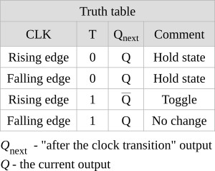

* **Code:**

library IEEE;

use IEEE.STD_LOGIC_1164.ALL;

entity tff is

Port ( clk : in STD_LOGIC;

async_reset : in STD_LOGIC;

Q : out STD_LOGIC);

end entity tff;

architecture toggle of tff is

signal S_Q : std_LOGIC := '0';

begin

process(clk, async_reset)

begin

if async_reset = '1' then

S_Q <= '0';

elsif rising_edge(clk) then

S_Q <= not S_Q;

end if;

end process;

Q <= S_Q;

end architecture toggle;

**\***: in this code I declared 2 inputs: clk for clock pin of circuit and the async_reset for reset pin of circuit. The output is Q which is next state of circuit. Reset pin Is asynchronous from clock pin and it is active high so it means when pin becomes 1 the output of circuit be 0. I used signals to work with outputs Q because we can not directly work with Q. signal is a wired in VHDL.

* **Output after compile**:

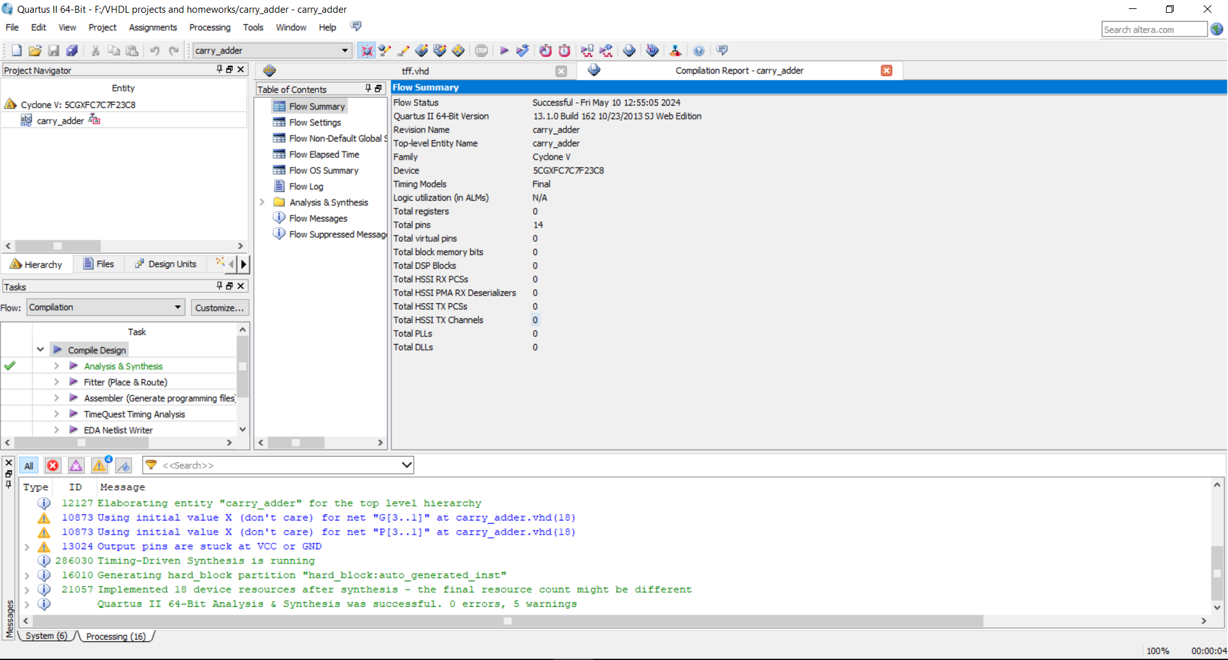

* **RTL view**:

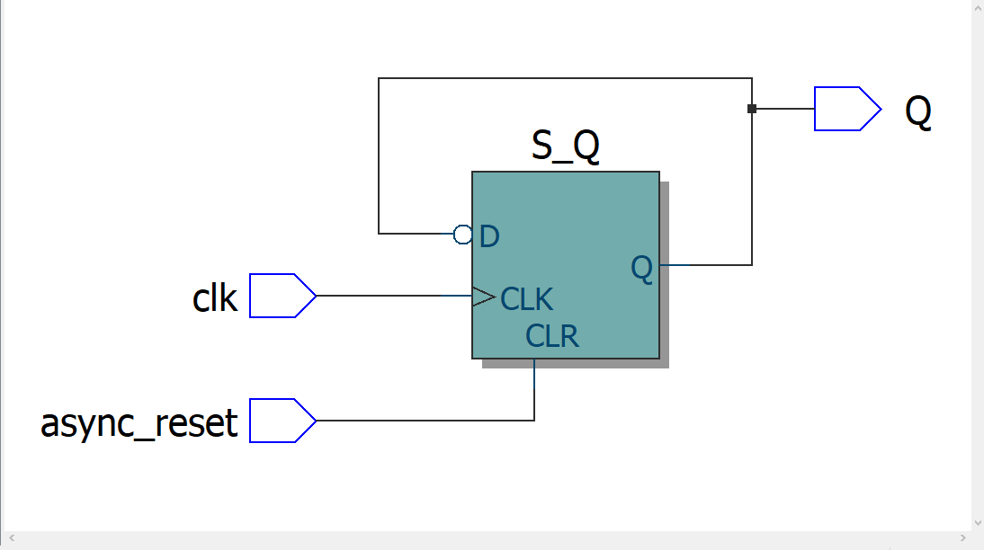

**\***: notice that in this code we built a T flip flop using D flip flop. This is achieved by feeding the output of the D Flip flop to its input through an XOR gate.

* **Post-mapping view**:

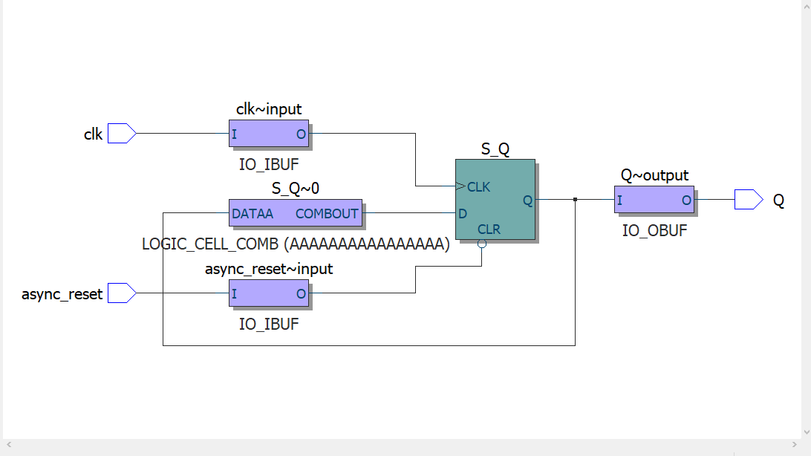

* **Wave Form:**

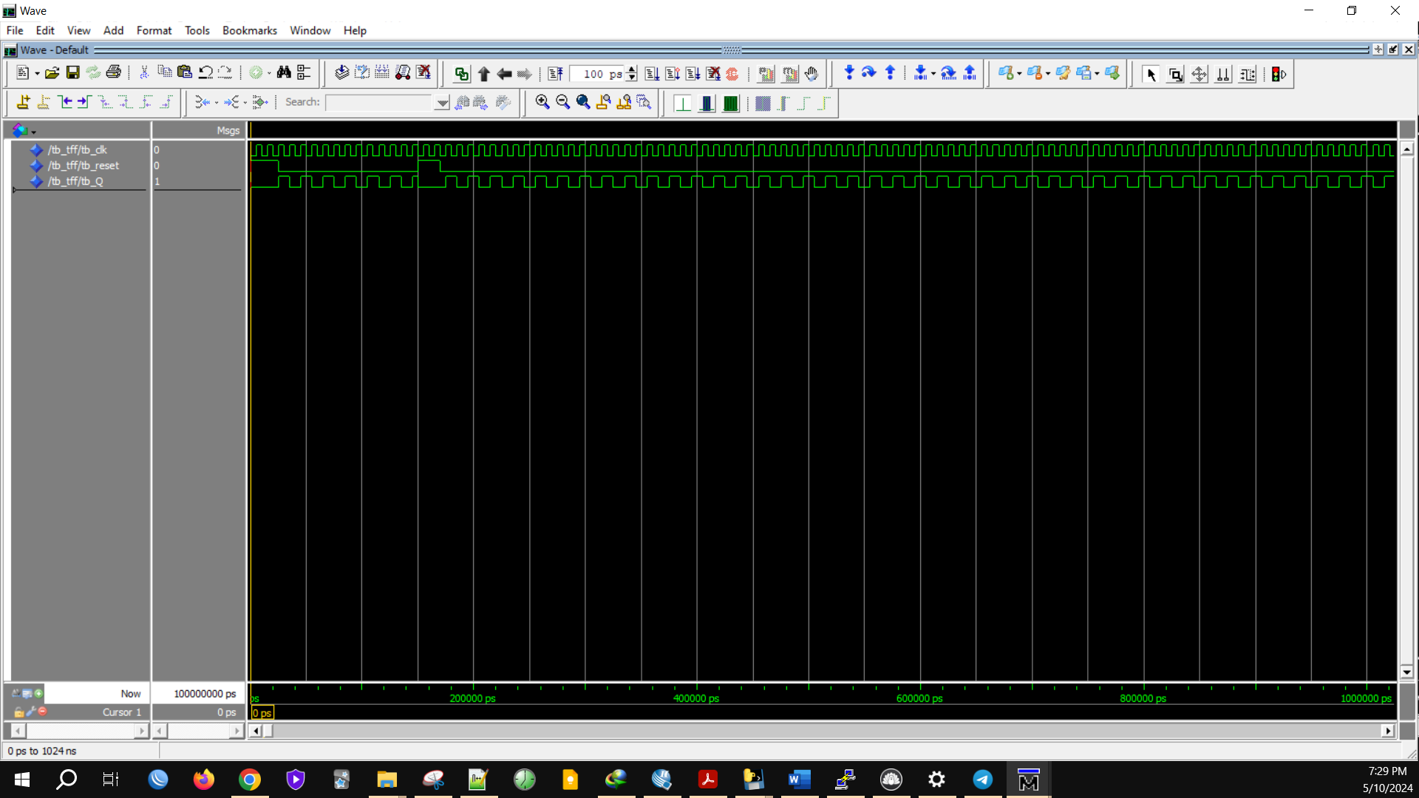

* **Test bench code:**

library IEEE;

use IEEE.STD_LOGIC_1164.ALL;

entity tb_tff is

-- Testbench does not have any ports

end tb_tff;

architecture behavior of tb_tff is

-- Component Declaration for the T Flip-Flop

component tff

Port ( clk : in STD_LOGIC;

async_reset : in STD_LOGIC;

Q : out STD_LOGIC);

end component;

-- Signals for interfacing with the component

signal tb_clk : STD_LOGIC := '0';

signal tb_reset : STD_LOGIC := '0';

signal tb_Q : STD_LOGIC;

-- Clock period definition

constant clk_period : time := 10 ns;

begin

-- Instantiate the T Flip-Flop

uut: tff port map (

clk => tb_clk,

async_reset => tb_reset,

Q => tb_Q

);

-- Clock process definitions

clk_process : process

begin

while true loop

tb_clk <= '0';

wait for clk_period/2;

tb_clk <= '1';

wait for clk_period/2;

end loop;

end process;

-- Stimulus process

stim_proc: process

begin

-- Test 1: Reset the flip-flop

tb_reset <= '1';

wait for 25 ns;

tb_reset <= '0';

wait for 25 ns;

-- Test 2: Allow some clock pulses to toggle the flip-flop

tb_reset <= '0';

wait for 100 ns;

-- Test 3: Assert reset while clock is running

tb_reset <= '1';

wait for 20 ns;

tb_reset <= '0';

wait for 100 ns;

-- End of testing

wait;

end process;

end behavior;

**question 3**

**Q3.** Designing a 4-bit BCD (Binary-Coded Decimal) up/down counter in VHDL involves creating a circuit that counts from 0 to 9 and back again, with the count direction controlled by an input signal **Dir**.

* **Code:**

library IEEE;

use IEEE.STD_LOGIC_1164.ALL;

use IEEE.STD_LOGIC_UNSIGNED.ALL;

entity BCD_Counter is

Port (

clk : in STD_LOGIC;

reset : in STD_LOGIC;

Dir : in STD_LOGIC; -- '0' for down, '1' for up

count : out STD_LOGIC_VECTOR(3 downto 0)

);

end BCD_Counter;

architecture Behavioral of BCD_Counter is

signal r_count : STD_LOGIC_VECTOR(3 downto 0) := "0000";

begin

process(clk, reset)

begin

if reset = '1' then

r_count <= "0000"; -- Reset the counter

elsif rising_edge(clk) then

if Dir = '1' then -- Count up

if r_count = "1001" then -- Max value for BCD

r_count <= "0000"; -- Wrap around

else

r_count <= r_count + 1;

end if;

else -- Count down

if r_count = "0000" then

r_count <= "1001"; -- Wrap around from 0 to 9

else

r_count <= r_count - 1;

end if;

end if;

end if;

end process;

count <= r_count; -- Output the current count

end Behavioral;

* **compilation report:**

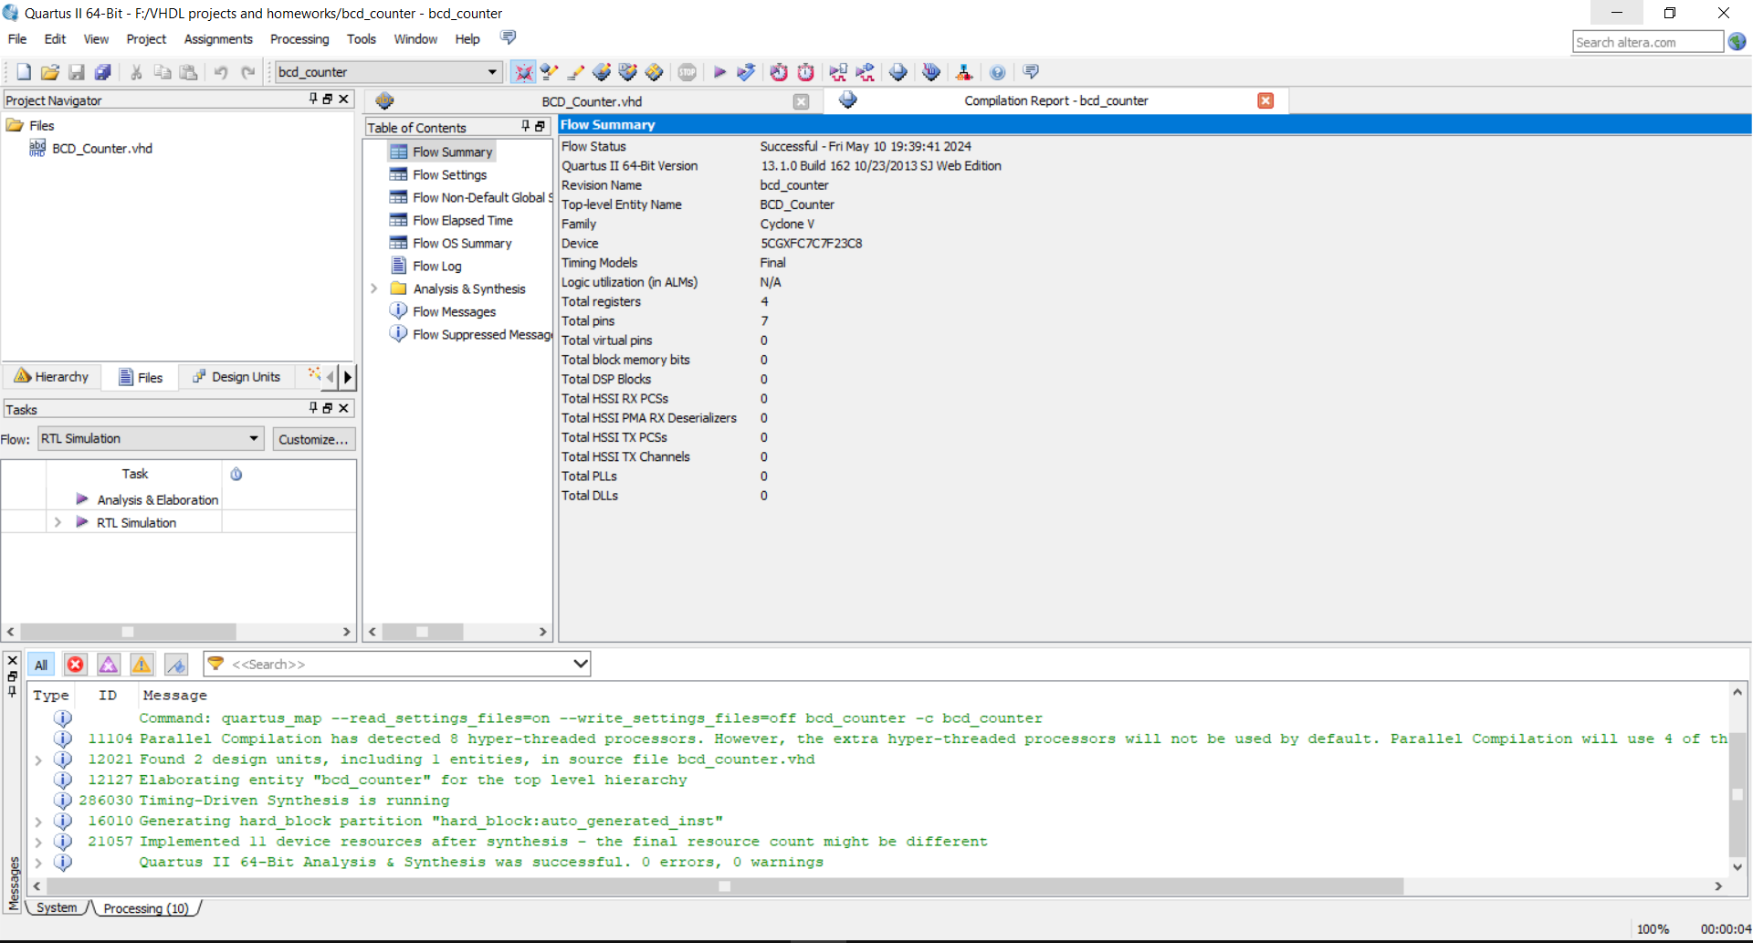

* **RTL view:**

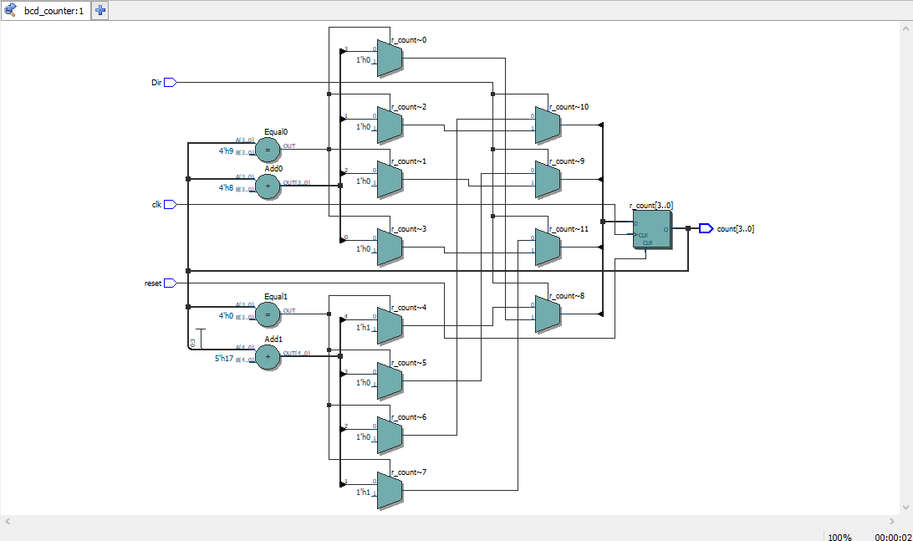

* **Post-mapping view:**

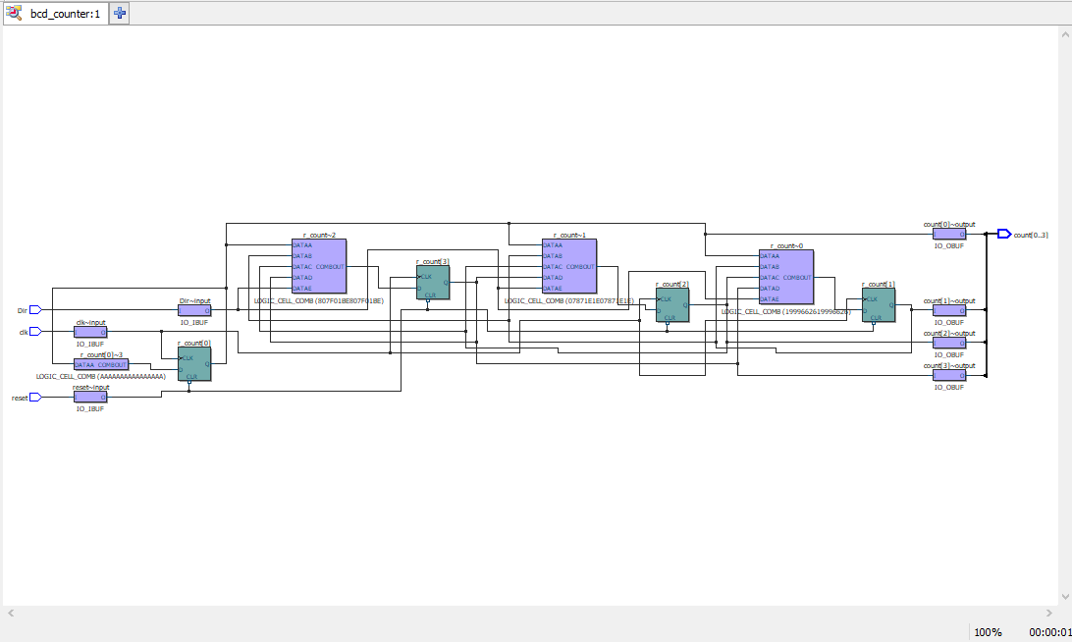

* **Wave form:**

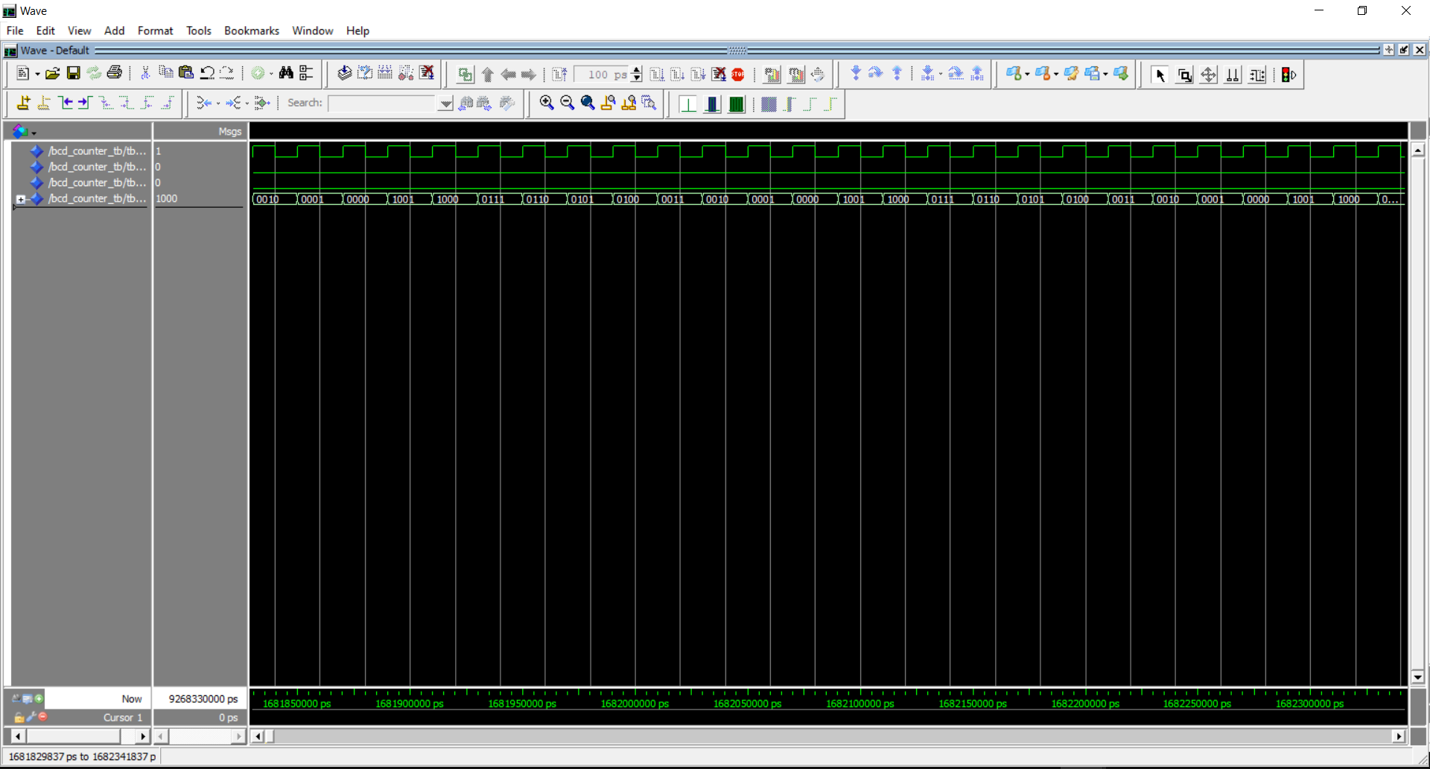

* **Test bench code:**

library IEEE;

use IEEE.STD_LOGIC_1164.ALL;

use IEEE.STD_LOGIC_UNSIGNED.ALL;

entity BCD_Counter_TB is

-- Testbench has no ports

end BCD_Counter_TB;

architecture behavior of BCD_Counter_TB is

-- Component Declaration

component BCD_Counter

Port (

clk : in STD_LOGIC;

reset : in STD_LOGIC;

Dir : in STD_LOGIC;

count : out STD_LOGIC_VECTOR(3 downto 0));

end component;

-- Test Signals

signal tb_clk : STD_LOGIC := '0';

signal tb_reset : STD_LOGIC := '0';

signal tb_Dir : STD_LOGIC := '0';

signal tb_count : STD_LOGIC_VECTOR(3 downto 0);

begin

-- Clock process

clk_process : process

begin

tb_clk <= '0';

wait for 10 ns; -- Clock period of 20 ns

tb_clk <= '1';

wait for 10 ns;

end process;

-- Instantiate the Unit Under Test (UUT)

uut: BCD_Counter port map (

clk => tb_clk,

reset => tb_reset,

Dir => tb_Dir,

count => tb_count);

-- Test Stimulus Process

stim_proc: process

begin

-- Initialize Inputs

tb_reset <= '1'; -- Assert reset initially

wait for 40 ns;

tb_reset <= '0'; -- De-assert reset

wait for 20 ns;

-- Test Count Up

tb_Dir <= '1'; -- Set direction to up

wait for 220 ns; -- Allow enough time to observe the count

-- Test Count Down

tb_Dir <= '0'; -- Change direction to down

wait for 220 ns; -- Allow enough time to observe the count

-- Finish simulation

wait;

end process;

end behavior;

**Question 4**

**Q4.** to write a VHDL code that implement pattern transformation for the given table I’ll create a state machine where each state corresponds to one of the input patterns and transition to the corresponding next pattern.

* **Code:**

library IEEE;

use IEEE.STD_LOGIC_1164.ALL;

-- Define the entity for the pattern transformation

entity Pattern_Finder is

Port (

clk : in STD_LOGIC;

reset : in STD_LOGIC;

input_pattern : in STD_LOGIC_VECTOR(2 downto 0);

next_pattern : out STD_LOGIC_VECTOR(2 downto 0)

);

end Pattern_Finder;

-- Architecture declaration using a behavioral model

architecture Behavioral of Pattern_Finder is

signal current_state, next_state : STD_LOGIC_VECTOR(2 downto 0);

begin

-- State register process

process(clk, reset)

begin

if reset = '1' then

current_state <= "000"; -- Default state

elsif rising_edge(clk) then

current_state <= next_state;

end if;

end process;

-- Next state logic based on current state

process(current_state)

begin

case current_state is

when "000" => next_state <= "011";

when "011" => next_state <= "110";

when "110" => next_state <= "101";

when "101" => next_state <= "111";

when "111" => next_state <= "000";

when others => next_state <= "000"; -- Safety net

end case;

end process;

-- Output logic

next_pattern <= next_state; -- Directly map next state to output

end Behavioral;

* **output after compilation:**

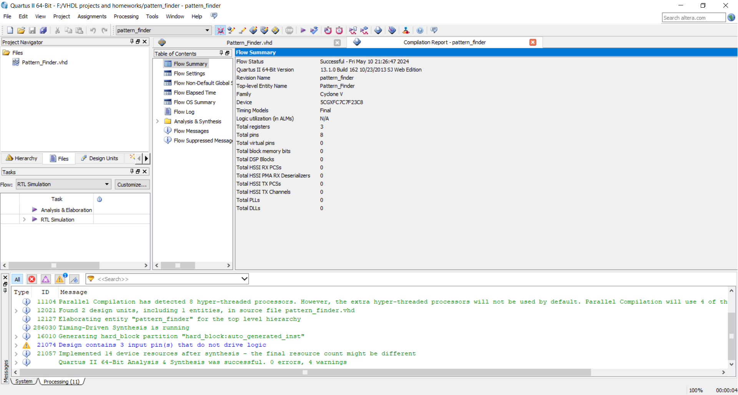

* **RTL view:**

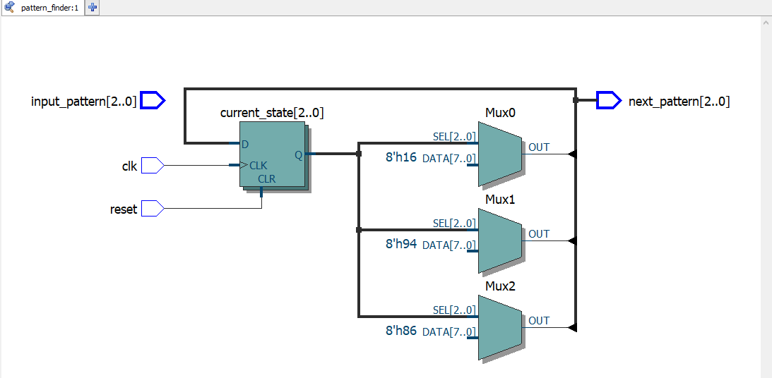

* **Post-mapping view:**

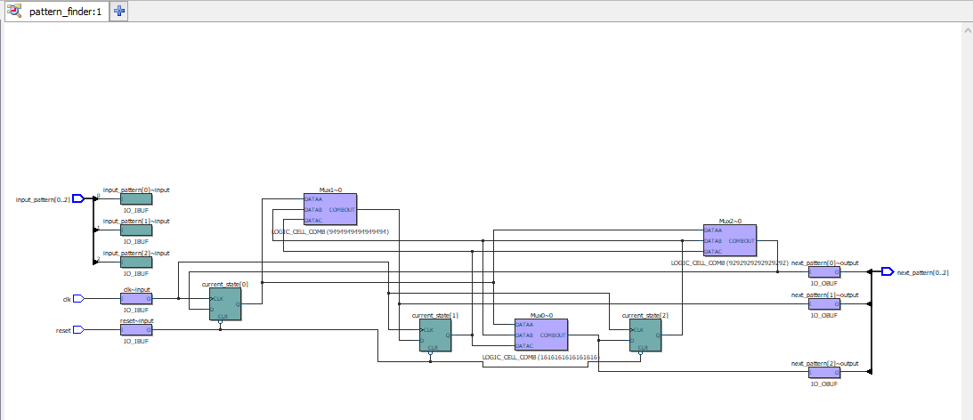

* **Wave form:**

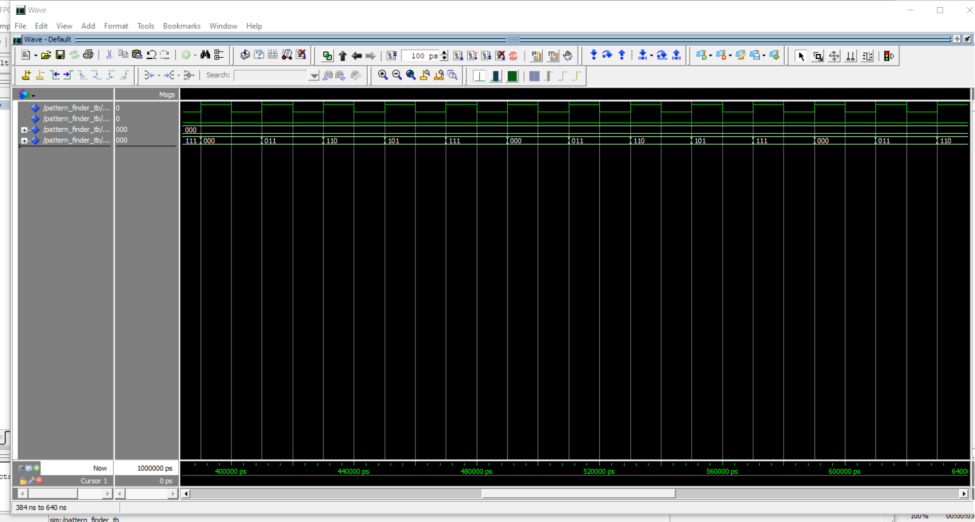

* **Test bench code:**

library IEEE;

use IEEE.STD_LOGIC_1164.ALL;

-- Define the test bench entity

entity Pattern_Finder_TB is

-- Testbench does not have any ports

end Pattern_Finder_TB;

architecture behavior of Pattern_Finder_TB is

-- Component Declaration for the Pattern_Finder

component Pattern_Finder

Port (

clk : in STD_LOGIC;

reset : in STD_LOGIC;

input_pattern : in STD_LOGIC_VECTOR(2 downto 0);

next_pattern : out STD_LOGIC_VECTOR(2 downto 0)

);

end component;

-- Signals for interfacing with the component

signal tb_clk : STD_LOGIC := '0';

signal tb_reset : STD_LOGIC := '0';

signal tb_input_pattern : STD_LOGIC_VECTOR(2 downto 0) := (others => '0');

signal tb_next_pattern : STD_LOGIC_VECTOR(2 downto 0);

begin

-- Clock process

clk_process: process

begin

while true loop

tb_clk <= '0';

wait for 10 ns; -- Clock period is 20 ns

tb_clk <= '1';

wait for 10 ns;

end loop;

end process;

-- Instantiate the Unit Under Test (UUT)

uut: Pattern_Finder port map (

clk => tb_clk,

reset => tb_reset,

input_pattern => tb_input_pattern,

next_pattern => tb_next_pattern

);

-- Stimulus process

stim_proc: process

begin

-- Reset the device

tb_reset <= '1';

wait for 25 ns; -- wait more than one clock cycle

tb_reset <= '0';

wait for 15 ns;

-- Loop through pattern states

tb_input_pattern <= "000"; -- Start at pattern "000"

wait for 20 ns; -- wait for one cycle

tb_input_pattern <= "011";

wait for 20 ns;

tb_input_pattern <= "110";

wait for 20 ns;

tb_input_pattern <= "101";

wait for 20 ns;

tb_input_pattern <= "111";

wait for 20 ns;

tb_input_pattern <= "000"; -- Wrap around

wait for 20 ns;

-- Finish the simulation

wait;

end process;

end behavior;